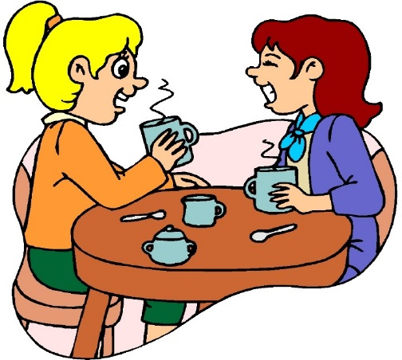
Una Conversazione Al Bar
Vocabolario Utile
Vorrei – I would like Quanto costa? – how much does xxxx cost?
Il conto per piacere – the bill please.
Instruzioni: Write a dialogue about two people going to a bar in Italy. The dialogue needs to contain the following:
- A greeting between the two bar-goers.
- They must decide whether to sit at a table or stand at the counter.
- They must give their order to the cashier or waiter. If you use the cashier you must get a receipt and present it to the barista. You must give the barista your order.
- Each order must contain 1 drink and 2 foods per person, no repeats.
- If you sat at the table, you must request the check and decide how to pay.
- You must say goodbye to the waiter or barista.
- YOU MUST ACT OUT YOUR DIALOGUE – I WILL BE THE WAITER/BARISTA
_____________________________________________________________________________________
_____________________________________________________________________________________
_____________________________________________________________________________________
_____________________________________________________________________________________
_____________________________________________________________________________________
_____________________________________________________________________________________
_____________________________________________________________________________________
_____________________________________________________________________________________
_____________________________________________________________________________________
_____________________________________________________________________________________

